
Federal Aviation
Administration

55054002

EN ROUTE
RADAR ASSOCIATE CONTROLLER TRAINING PART B: NONRADAR

Lesson 3: Initial Separation of Arrivals and Departures

Version: 1.0 2022.08

PAGE INTENTIONALLY LEFT BLANK

Lesson Plan Data Sheet

Course Name | En Route Radar Associate Controller Training Part B: Nonradar
Course Number | 55054002
Lesson Title | Initial Separation of Arrivals and Departures
Duration | 45 minutes (includes lesson and ELT)
Version | 1.0 2022.08
Reference(s) | JO 7110.65, Air Traffic Control
Prerequisites | NONE
Handout(s) | NONE
Exercise / Activity | NONE
Scenario | NONE
Assessments | - YES - Written
Materials and Equipment | - Pencil and/or pen
Other Pertinent Information | - Ensure lesson materials are downloaded to the classroom computer  - Course 57839 - INITIAL SEPARATION of DEPARTURES and ARRIVALS, or current course, is available as supplemental training for this lesson  - This lesson is based on ERAM EAE410  - The lesson has been reviewed and reflects current orders and manuals as of April 2022
 As you prep for this lesson, recall and be prepared to talk about examples and personal experiences that illustrate or explain the teaching points in the lesson.

Lesson Icon Legend

 | Description
 | The Activity icon indicates an exercise, lab, or hands-on activity.
 | The Discussion Question icon signals a discussion question to be asked to the students.
 | The Handout icon indicates a handout is to be distributed to the students.
 | The Instructor Note icon is in hidden text and indicates text that is for the instructor only.
 | The Multimedia icon indicates a video or audio clip is in the presentation.
 | The Phraseology icon indicates that phraseology is in the content.
 | The WBT icon indicates a component of web-based training.
 | The Click icon indicates a PPT slide with click-based functionality to present additional information.
 | The Definition icon indicates a published definition.

PAGE INTENTIONALLY LEFT BLANK

Lesson Introduction

Overview
JO 7110.65, par. 2-1-3

1

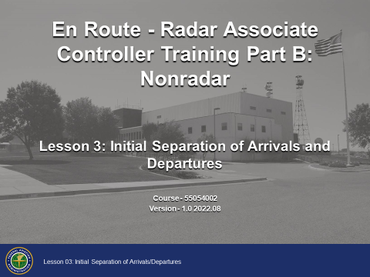

Overview
Learning to use the nonradar procedures contained in this lesson will enable you to provide a safe, orderly, and expeditious flow of traffic, when an operational advantage will be gained over radar procedures.
This lesson will cover the rules and procedures for providing initial separation between successive departures and a departure and an arrival.

Lesson Objectives

2

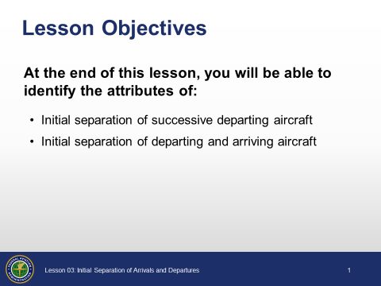

Objectives
Review the lesson objectives.
- At the end of this lesson, you will be able to identify the attributes of:
- Initial separation of successive departing aircraft
- Initial separation of departing and arriving aircraft
NOTE: There will be a graded end-of-lesson test upon completion of the lesson. The passing score is 70%. If you do not achieve a score of 70%, you will be provided study time and one retake of an alternate end-of-lesson test.

Initial Separation of Successive Departing Aircraft

Minima on Diverging Courses
JO 7110.65, par. 6-2-1

3

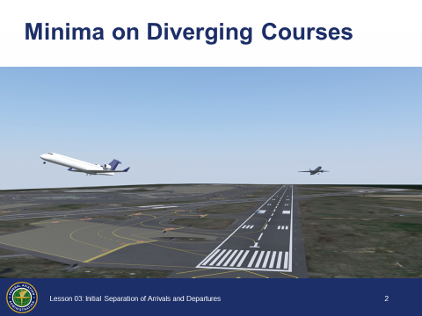

Minima on Diverging Courses
- Courses must diverge by 45 degrees or more after departure from adjacent or same airport to use the initial separation procedures
- Consider known aircraft performance characteristics when applying initial separation to successive departing aircraft
- When one or both of the departure surfaces is a helipad, use the takeoff course of the helicopter as a reference, comparable to the centerline of a runway and the helipad center as the threshold
NOTE: Controllers can make courses diverge by issuing turns and headings.

1-Minute Separation
JO 7110.65, par. 6-2-1

4

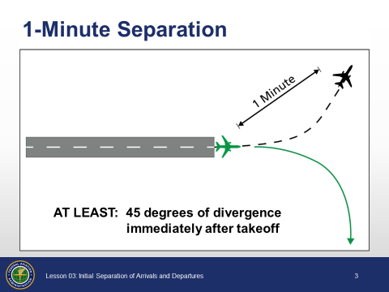

1-Minute Separation
- When aircraft will fly diverging courses by 45 degrees or more immediately after takeoff
- Use 1 minute separation until courses diverge
Example: “SKYHAWK FIVE FOUR SEVEN RELEASED ONE MINUTE AFTER BARON TWO THREE TANGO DEPARTS”

2-Minute Separation
JO 7110.65, par. 6-2-1

5

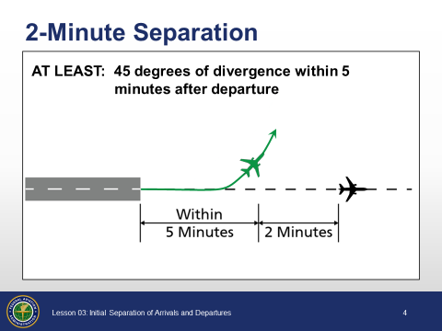

2-Minute Separation
- When aircraft will fly diverging courses by 45 degrees or more within 5 minutes after takeoff:
- Use 2 minutes separation until courses diverge
Example: “NOVEMBER ONE TWO THREE RELEASED TWO MINUTES AFTER NOVEMBER FOUR FIVE SIX DEPARTS”

3-Mile DME/ATD Separation
JO 7110.65, par. 6-2-1, PCG

6

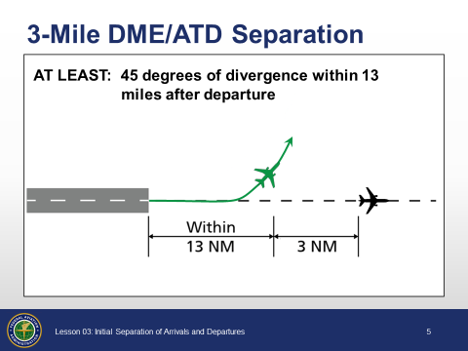

3-Mile DME/ATD Separation
- When aircraft will fly diverging courses within 13 miles DME/ATD after takeoff:
- Use 3 miles separation until courses diverge by 45 degrees or more

Minima On Same Course
JO 7110.65, par. 6-2-2

7

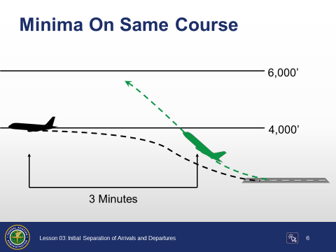

This is an animated slide, 1 click.
Minima on Same Course
- Separate departing aircraft that will fly the same course when the following aircraft will climb through the altitude assigned to the leading aircraft by using a minimum of either:
- 3 minutes until the following aircraft passes through the assigned altitude of the leading aircraft, or
Click to change from 3 Minutes to 5 Miles.
- 5 miles until the following aircraft passes through the assigned altitude of the leading aircraft between:
- DME equipped aircraft
- RNAV equipped aircraft using ATD
- DME and ATD aircraft provided the DME aircraft is either:
- At or below 10,000’, or
- Farther than 10 miles from the DME NAVAID

Knowledge Check

8

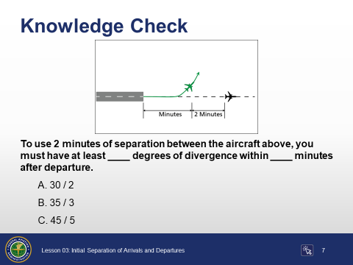

Question: To use 2 minutes of separation between the aircraft above, you must have at least ____ degrees of divergence within ____ minutes after departure.
Answer: C. 45 / 5

Knowledge Check

9

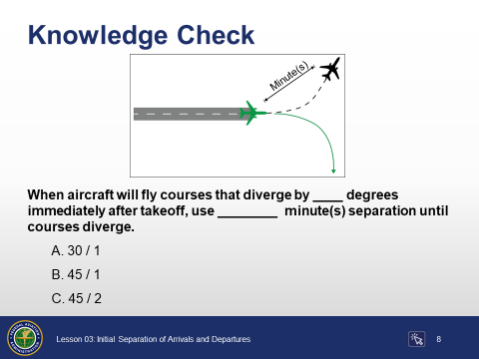

Question: When aircraft will fly courses that diverge by ____ degrees immediately after takeoff, use ________ minute(s) separation until courses diverge.
Answer: B. 45 / 1

Knowledge Check

10

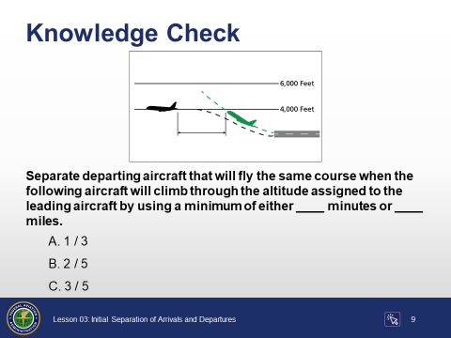

Question: Separate departing aircraft that will fly the same course when the following aircraft will climb through the altitude assigned to the leading aircraft by using a minimum of either ____ minutes or ____ miles.
Answer: C. 3 / 5

Knowledge Check

11

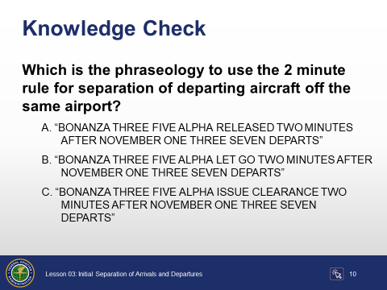

Question: Which is the phraseology to use the 2 minute rule for separation of departing aircraft off the same airport?
Answer: A. “BONANZA THREE FIVE ALPHA RELEASED TWO MINUTES AFTER NOVEMBER ONE THREE SEVEN DEPARTS”

Initial Separation of Departing and Arriving Aircraft

Departure and Arrival
JO 7110.65, par. 6-3-1

12

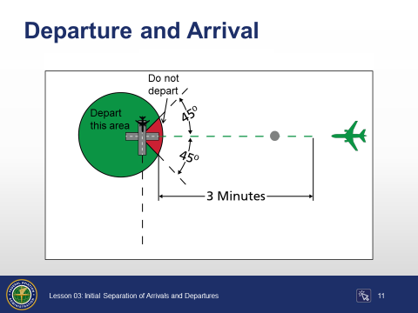

This is an animated slide, 1 click.
Departure and Arrival
- Separate a departing aircraft from an arriving aircraft making an instrument approach to the same airport by using the following minima until vertical or lateral separation is achieved:
- When takeoff direction differs by at least 45 degrees from the reciprocal of the final approach course:
- Aircraft must depart at least 3 minutes before the arriving aircraft is estimated at the airport
Click to reveal the do not depart area when arrival is within 3 minutes of the airport.
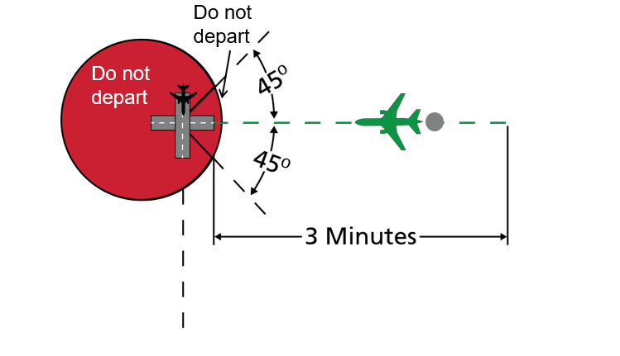

Departure and Arrival (Cont’d)
JO 7110.65, pars. 6-3-1, 7-2-1

13

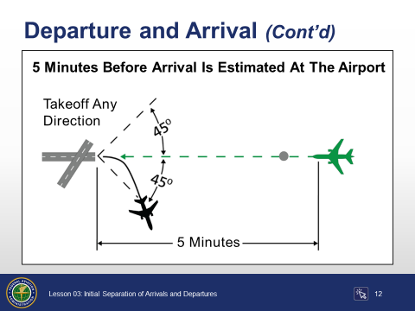

This is an animated slide, 1 click.
- When takeoff direction does not differ by at least 45 degrees from the reciprocal of the final approach course:
- Departing aircraft must be established on a course diverging by at least 45 degrees from the reciprocal of the final approach course:
- 5 minutes before the arriving aircraft is estimated at the airport, or
Click to reveal the Before Arrival Starts Procedure Turn graphic.
- Before arrival starts procedure turn
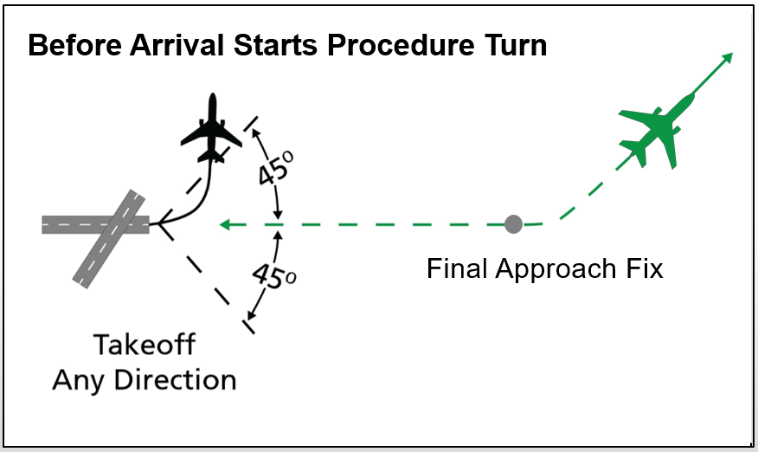
- Visual separation
- Nonapproach control towers may be authorized to provide visual separation between aircraft within surface areas or designated areas when approved separation is provided before and after the application of visual separation

Knowledge Check

14

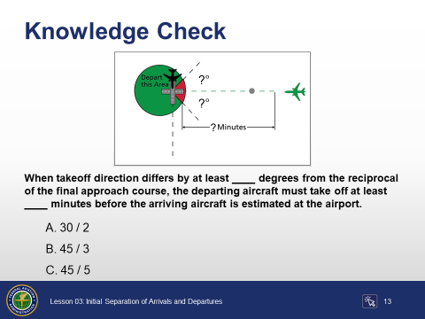

Question: When takeoff direction differs by at least ____ degrees from the reciprocal of the final approach course, the departing aircraft must take off at least ____ minutes before the arriving aircraft is estimated at the airport.
Answer: B. 45 / 3

Knowledge Check

15

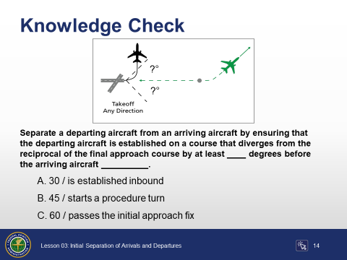

Question: Separate a departing aircraft from an arriving aircraft by ensuring that the departing aircraft is established on a course that diverges from the reciprocal of the final approach course by at least ____ degrees before the arriving aircraft __________.
Answer: B. 45 / starts a procedure turn

Timed Approaches
Timed Approaches
JO 7110.65, par. 6-7-1

16

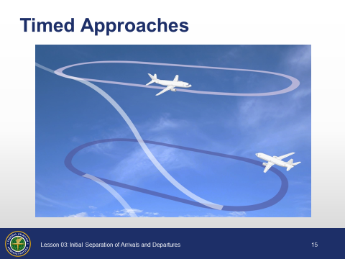

Timed Approaches

- Timed approaches using either nonradar procedures or radar vectors to the final approach course may be used at airports served by a tower if the following conditions are met:
- Direct communication is maintained with the aircraft until the pilot is instructed to contact the tower
- If more than one missed approach procedure is available, none require course reversal
- If only one missed approach procedure is available, the following conditions are met:
- Course reversal is not required
- Reported ceiling and visibility are equal to or greater than the highest prescribed circling minimums for the instrument approach procedure in use
- Timed Approach procedures require NAVAIDs and standard/special instrument approach procedures or adequate radar coverage which permit an aircraft to:
- Hold at a fix located on the approach course or be radar vectored to the final approach course for a straight-in approach, then
- Proceed in the direction of the airport along the approach course crossing the holding/approach fix at a specified altitude, if required, then
- Continue descent for an approach to destination airport

Knowledge Check

22

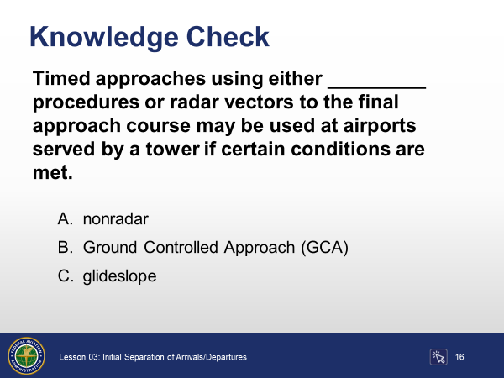

Question: Timed approaches using either _________ procedures or radar vectors to the final approach course may be used at airports served by a tower if certain conditions are met.
Answer: A. nonradar

Conclusion

Lesson Summary

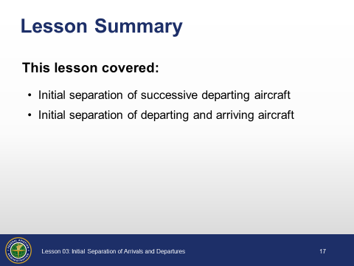

Review and elaborate briefly on the following topics. Ask students if they have questions about any of the concepts covered in the lesson.
Summary
- Initial separation of successive departing aircraft
- Minima on diverging courses
- 1-minute separation
- 2-minute separation
- 3-mile DME/ATD separation
- Minima on same courses
- 3-minute separation
- 5-mile DME/ATD separation
- Initial separation of departing and arriving aircraft
- 3 minutes before arrival is estimated at the airport
- 5 minutes before arrival is estimated at the airport
- Before arrival starts procedure turn
- Nonapproach control towers - Visual separation
- Timed approaches
Hand out and administer the End-of-Lesson Test. Provide feedback on missed items, including why particular answers are correct, as well as why some responses are incorrect.

